
Name: Muhammad Zain
CU-4353-2023
BSSE-2023-C
Last Task 1
- Area of a Circle
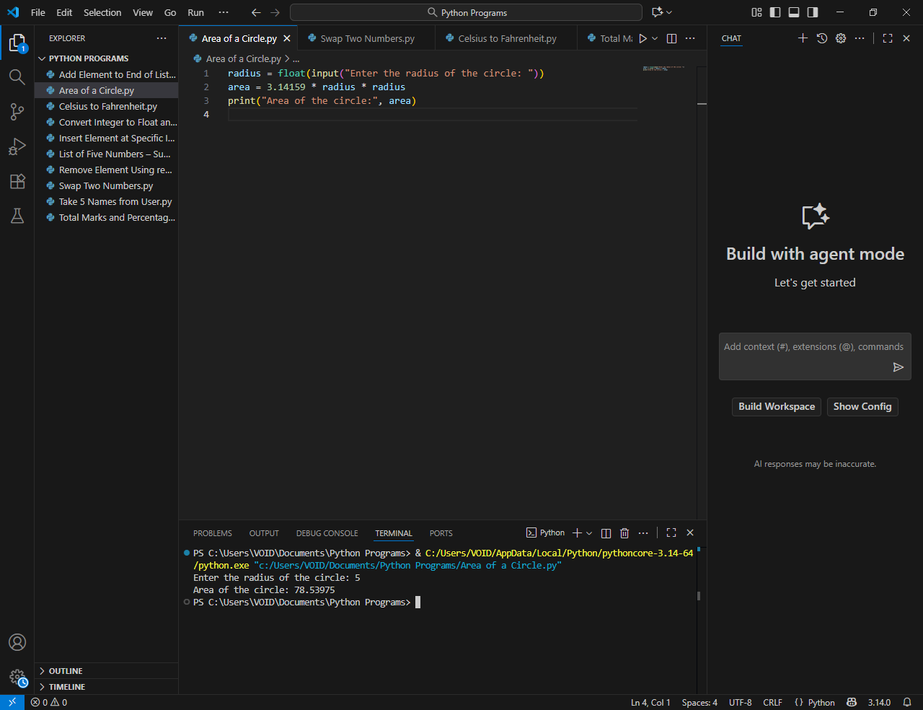
- Swap Two Numbers
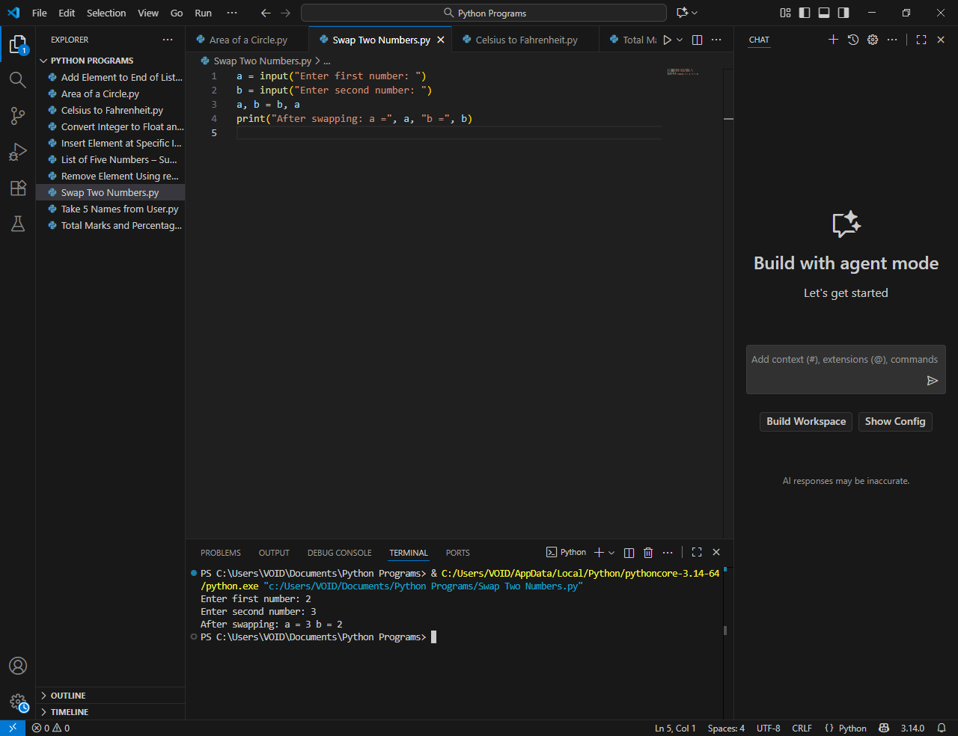

- Celsius to Fahrenheit
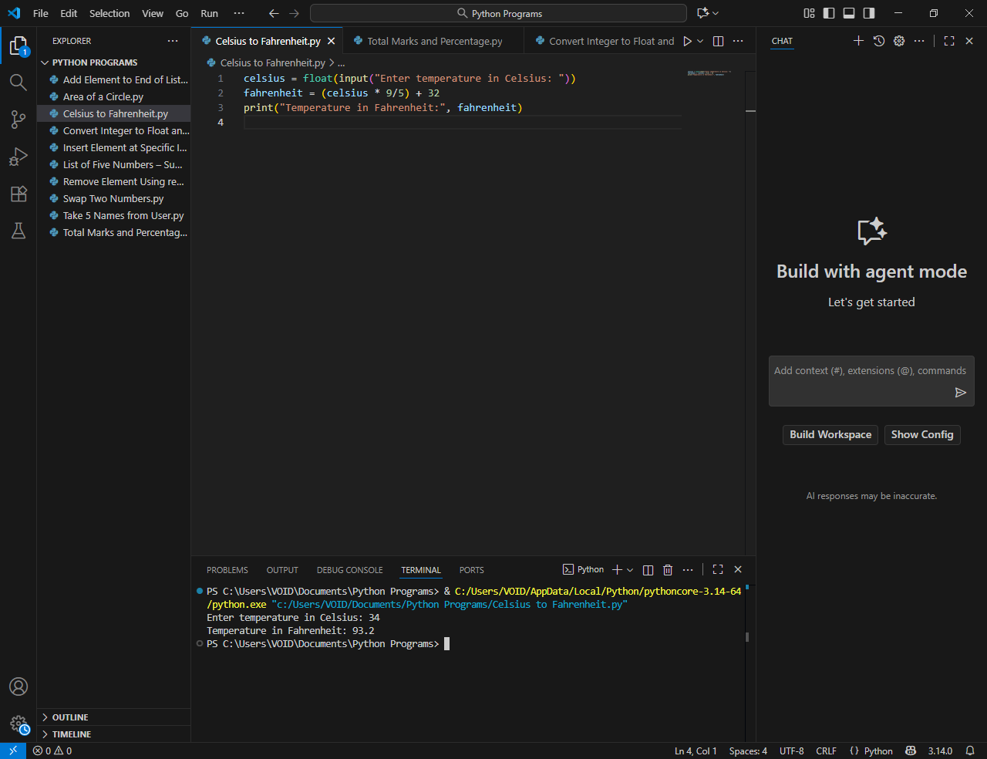
- Total Marks and Percentage

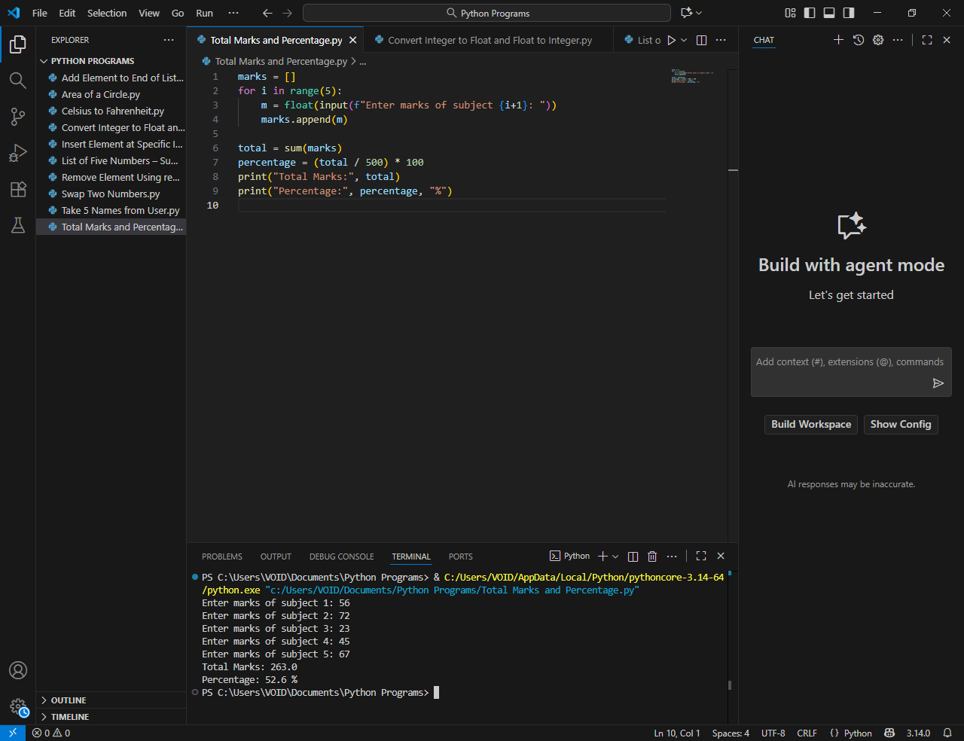
- Convert Integer to Float and Float to Integer
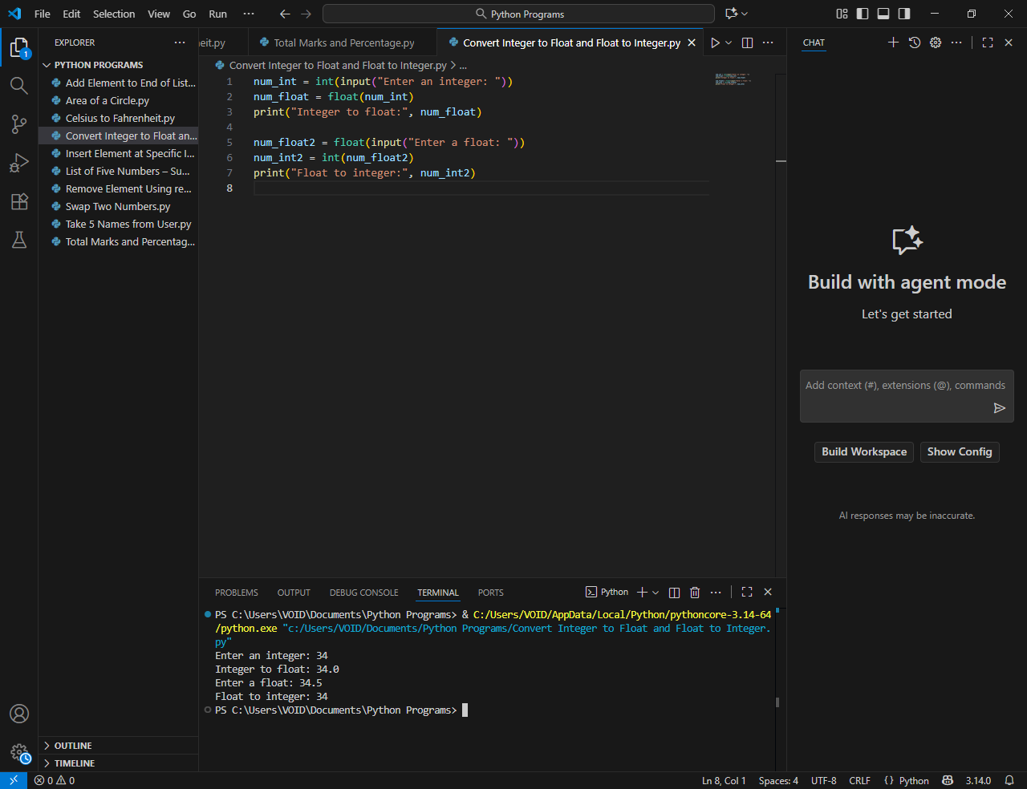
- List of Five Numbers – Sum, Max, Min

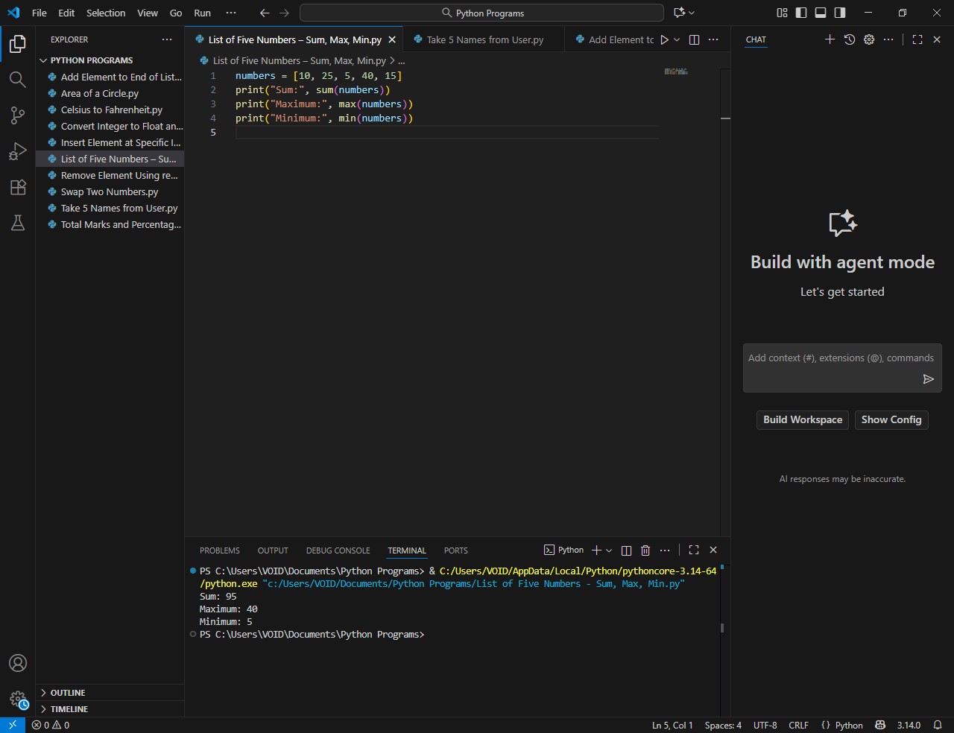
- Take 5 Names from User
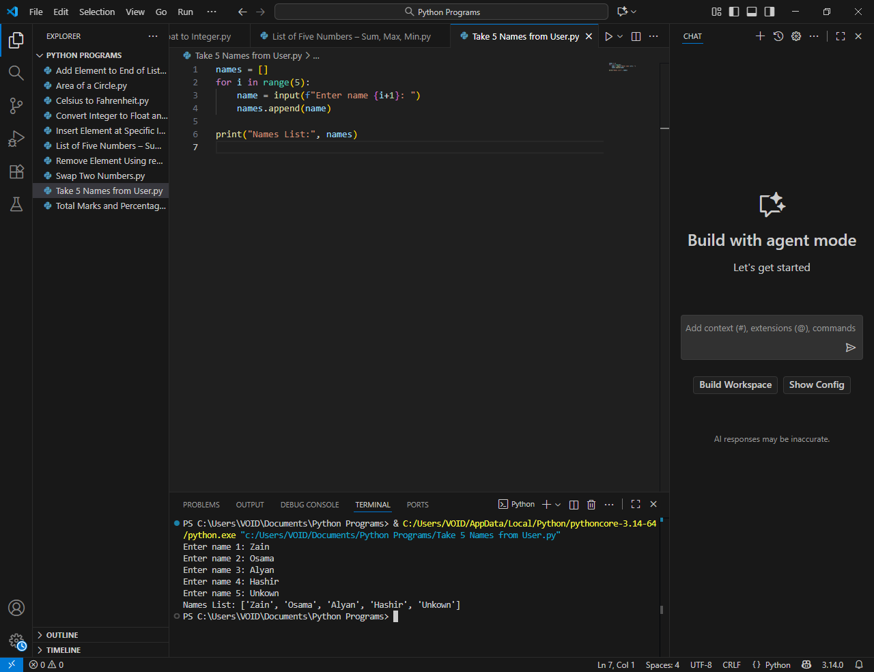
- Add Element to End of List (append)
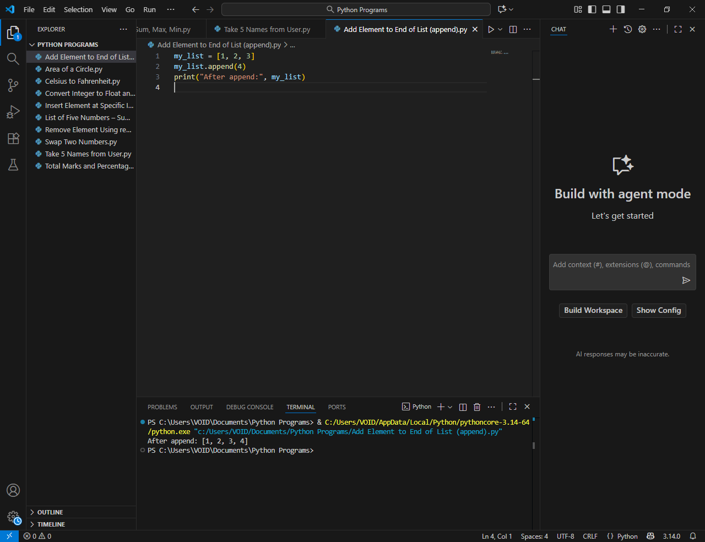
- Insert Element at Specific Index
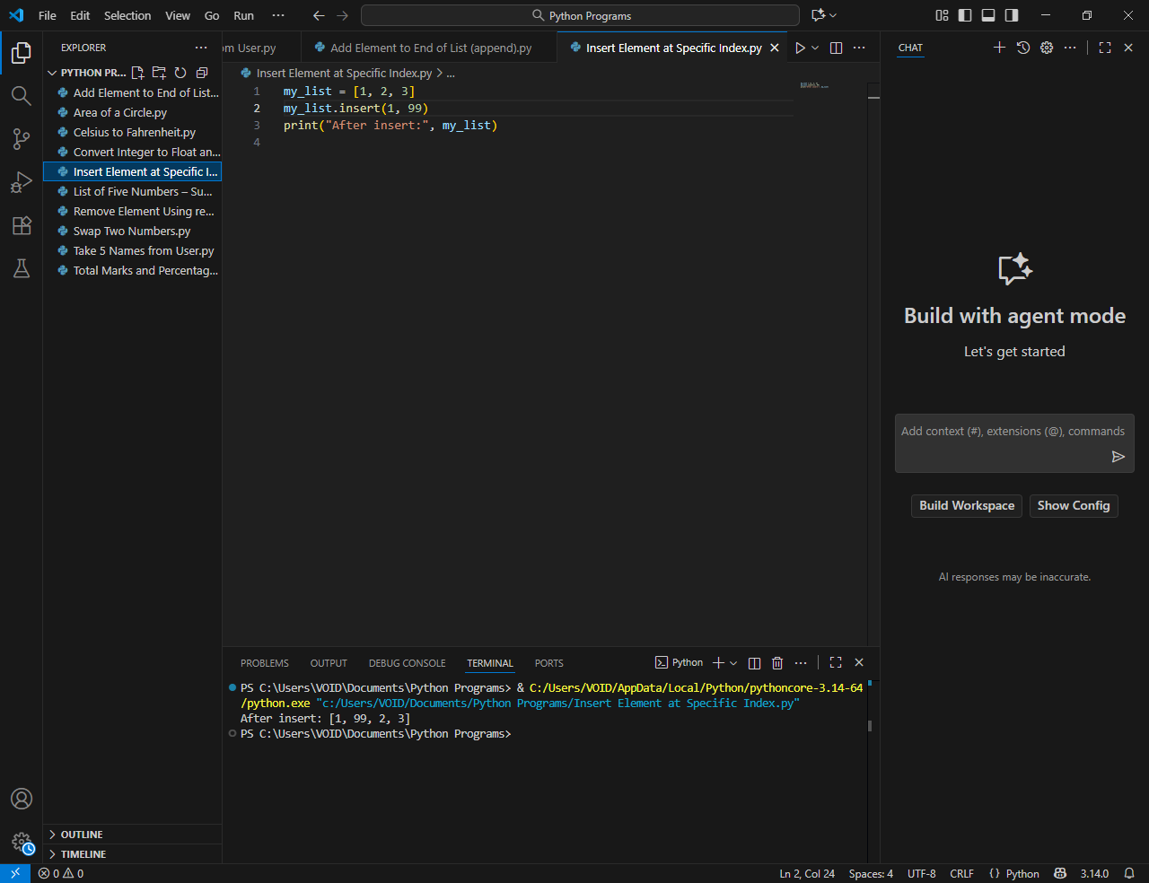
10.Remove Element Using remove() and pop()
